TIMSS Variable Notes (Draft)

1. Context
These notes summarize variable availability and coding based on official TIMSS documentation. They are intended to clarify:
- Which variables are used in the master tables.
- Which countries and years are excluded due to missing files or missing values.
- How missing information is handled (documented and acknowledged rather than imputed at the country level).
Not all countries participate in every TIMSS cycle, and not all background questionnaires are available for all participating countries. These limitations are explicitly recorded and reflected in the analysis.
Current scope of the analysis:
- Grade: 4 only
- Years: 2019 and 2023 (2015 used only for sensitivity checks)
- Region: Europe and the Balkans

2. Key Sources Reviewed
- TIMSS 2019 Grade 4 codebook: TIMMS GUIDES/TIMSS2019_IDB_SPSS_G4/.../Codebooks/T19_G4_Codebook.xlsx
- TIMSS 2023 Grade 4 codebook: TIMMS GUIDES/TIMSS2023_IDB_R_G4/.../T23_Codebook_G4.xlsx
- Working variable extraction table: WB_TIMMS/variable_names.txt

3. Summary of Completed Analyses
3.1 Parental Education Measure Comparison
Two binary parental education measures were compared as predictors of student achievement:
- Parent B / Mother’s Education
  - parentB_high_edu (2019 and 2023)
  - mother_high_edu (2015)
- Maximum of Both Parents’ Education
  - ASDHEDUP_binary
Both measures are recoded to a binary scale:
- 1 = upper secondary education or higher (ISCED 4+)
- 0 = below upper secondary education
3.1.1 Correlation Results
Year | Correlation (r) | N (country–outcome pairs)
2015 | ~0.98 | ~60
2019 | ~0.97 | ~80
2023 | ~0.98 | ~80
Key finding: Correlations between beta coefficients obtained using the two measures are consistently above 0.95 across all years and all four achievement domains (Mathematics, Science, Mathematics Reasoning, Science Reasoning).
This indicates that:
- The two measures produce nearly identical estimates of SES-related achievement gaps.
- The educational attainment of the primary responding parent (typically the mother or Parent B) captures almost all of the variation contained in the maximum-of-two-parents measure.
- Either measure can be used for substantive analysis without affecting conclusions.
3.1.2 Missing Data and Coverage
Year | Variable | Approx. % Valid | Main reason for missingness
2019 | Parent B education | ~85% | Parent B not present or did not respond
2019 | Max of two parents (ASDHEDUP) | ~92% | Derived from either parent’s response
2023 | Parent B education | ~84% | Parent B not present or did not respond
2023 | Max of two parents (ASDHEDUP) | ~91% | Derived from either parent’s response
2015 | Mother’s education (ASBH20B) | ~80% | Mother did not respond to home questionnaire
2015 | Max of two parents (ASDHEDUP) | ~88% | Derived variable with broader coverage
Explanation: ASDHEDUP is a TIMSS-derived variable defined as the highest education level reported by either parent. It is missing only when neither parent provides education information, making it more robust to single-parent households and partial survey responses.

4. Justification for Excluding 2015 from the Main Analysis
Although 2015 data were analyzed for comparison purposes, the main analysis focuses on 2019 and 2023. The reasons are outlined below.
4.1 Differences in Country Participation
Several Balkan countries (Albania, Bosnia-Herzegovina, Kosovo, Montenegro, North Macedonia) first participated in TIMSS Grade 4 in 2019. As a result, 2015 data provide incomplete regional coverage for the Balkans, which are a core focus of this study.
Summary counts (Grade 4, Europe + Balkans):
- 2015: 21 countries
- 2019: 27 countries
- 2023: 26 countries
4.2 Absence of an Official SES Index in 2015
- 2023 provides the official ASDHSES Home Socioeconomic Status Index.
- 2019 does not include ASDHSES, but all required component variables are available, allowing replication of the 2023 methodology.
- 2015 uses different variable names, coding schemes, and home possessions items, and no official SES construction methodology is provided.
This makes harmonization of SES across 2015 and later cycles problematic and increases the risk of measurement error.
4.3 Questionnaire and Coding Differences
- 2015 refers explicitly to “Mother” and “Father”, while 2019 and 2023 use “Parent/Guardian A” and “Parent/Guardian B”.
- Education coding scales differ across cycles.
- Home resource questions are not fully comparable.
4.4 Reasoning Plausible Values
Math and Science Reasoning plausible values were revised and formally introduced in 2019. While 2015 includes some reasoning items, construct definitions and scaling differ, limiting comparability.
4.5 Recommendation
The main analysis should rely on 2019 and 2023 data because they offer:
- Consistent country participation, especially for Balkan countries.
- Harmonizable SES measurement.
- Comparable questionnaire structure.
- Methodologically aligned reasoning achievement scales.
The 2015 analysis is retained as a sensitivity check demonstrating the stability of results over time.

5. Education and SES Variables
5.1 Parents’ Highest Education (ASDHEDUP)
- Label (2019 G4 codebook): Parents’ Highest Education Level.
- Coding (2019):
  - 1 University or higher
  - 2 Post-secondary but not university
  - 3 Upper secondary
  - 4 Lower secondary
  - 5 Some primary or no school
  - 6 Not applicable
  - 9 Omitted or invalid
Lower numeric codes correspond to higher education in 2011–2019. For 2023, the scale is reversed and mapped in code to ensure higher values always indicate higher education.
5.2 Home Socioeconomic Status Index (ASDHSES, 2023)
TIMSS 2023 provides an official three-category SES index:
- 1 = Higher
- 2 = Middle
- 3 = Lower
For analysis, this variable is also mapped to a numeric scale where higher values indicate higher SES.
5.3 Replication of SES for 2019
Because ASDHSES is not available in 2019, a comparable index is constructed using the methodology from TIMMS at year 2023:
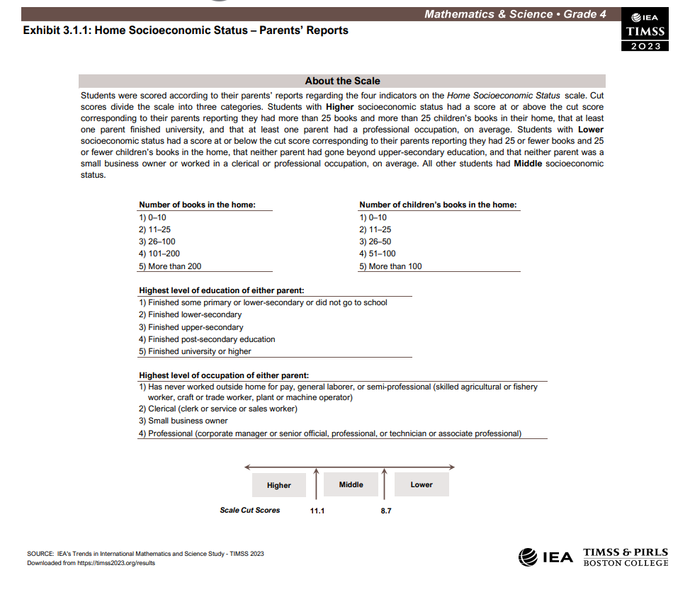
6. Outcomes and Methodology
6.1 Achievement Outcomes
- Mathematics: *MMAT01–*MMAT05
- Science: *SSCI01–*SSCI05
- Mathematics Reasoning: *MREA01–*MREA05
- Science Reasoning: *SREA01–*SREA05
6.2 Regression Framework
- Survey-weighted regressions using TIMSS sampling weights (TOTWGT).
- Jackknife replicate design with school and strata identifiers.
- Achievement percentiles computed at both regional and country levels.
- Models estimated separately by country, year, outcome, and predictor.

7. Scripts and Outputs
Main Scripts
- BUILD_MASTER_TABLES.R: Builds cleaned master datasets and percentiles.
- WB_ANALYSIS.R: Runs weighted regressions and generates tables.
- ANALYZE_2015.R: Processes 2015 data for comparison.
- COMPARE_EDUCATION_MEASURES.R: Compares education measures.
- DATA_QUALITY_PLOTS.R: Generates missingness and data quality plots.
Output Folders
- output/tables/: Regression result tables.
- comparison_plots/: Scatter plots and correlation summaries.
- data/processed_data/: Master datasets by year.

8. Executive Conclusion
Across all years and achievement domains, parental education measures based on a single responding parent and on the maximum of both parents’ education produce nearly identical estimates of achievement gaps. Given its better coverage and official status, the maximum-of-two-parents measure (ASDHEDUP_binary) is recommended for the main analysis, with results shown to be robust to alternative specifications.

9. Country Participation and Coverage by Cycle (Methodological Relevance)
Country participation differs substantially across TIMSS cycles. This is a key methodological constraint because the regional focus of the analysis (Europe and the Balkans) depends on having consistent country coverage across years.
The table below summarizes Grade 4 participation for European and Balkan countries in each cycle:
Country | 2015 | 2019 | 2023
Albania | – | ✓ | ✓
Austria | – | ✓ | –
Bosnia-Herzegovina | – | ✓ | ✓
Bulgaria | ✓ | ✓ | ✓
Croatia | ✓ | ✓ | –
Cyprus | ✓ | ✓ | ✓
Czech Republic | ✓ | ✓ | ✓
Denmark | ✓ | ✓ | ✓
Finland | ✓ | ✓ | ✓
France | ✓ | ✓ | ✓
Germany | ✓ | ✓ | ✓
Hungary | ✓ | ✓ | ✓
Ireland | ✓ | ✓ | ✓
Italy | ✓ | ✓ | ✓
Kosovo | – | ✓ | ✓
Latvia | – | ✓ | ✓
Lithuania | ✓ | ✓ | ✓
Malta | – | ✓ | –
Montenegro | – | ✓ | ✓
Netherlands | ✓ | ✓ | ✓
North Macedonia | – | ✓ | ✓
Norway | ✓ | ✓ | ✓
Poland | ✓ | ✓ | ✓
Portugal | ✓ | ✓ | ✓
Romania | – | – | ✓
Serbia | ✓ | ✓ | ✓
Slovakia | ✓ | ✓ | ✓
Slovenia | ✓ | – | ✓
Spain | ✓ | ✓ | ✓
Sweden | ✓ | ✓ | ✓
UK (England) | ✓ | ✓ | ✓
Belgium (Flemish) | ✓ | ✓ | ✓
Georgia | ✓ | ✓ | ✓
Summary counts (Grade 4, Europe + Balkans):
- 2015: 21 countries
- 2019: 27 countries
- 2023: 26 countries
Methodological implication: Several Balkan countries (Albania, Bosnia-Herzegovina, Kosovo, Montenegro, North Macedonia) enter the Grade 4 TIMSS sample only from 2019 onward. As a result, 2015 does not support balanced Europe–Balkans comparisons and is unsuitable for regional trend analysis.

10. Handling of Missing Files and Missing Values
Some countries do not provide complete background files (e.g., missing ASH* home questionnaire files) in specific years. These cases are handled as follows:
- Missing background files are logged explicitly.
- Countries with missing files remain in the dataset but have missing values for affected background variables.
- No country-level imputation is performed.
For SES components, missing values are treated conservatively:
- When at least one SES component is observed, missing components are imputed using the school-year mean, falling back to the country-year mean.
- SES is set to missing only when all components are missing.
This approach preserves sample size while avoiding artificial equalization across countries.

11. Percentile Construction (Key Analytical Step)
Achievement outcomes are transformed into percentile ranks prior to regression analysis:
- Region percentiles: computed pooling all students from Europe and the Balkans within a given year.
- Country percentiles: computed within each country-year.
Both versions are retained and used in parallel regressions. This allows direct assessment of whether estimated SES or education gaps are sensitive to the reference distribution. Results are roughly the same, hence we are keeping regional percentiles.
Percentiles are computed once in BUILD_MASTER_TABLES.R and reused in all subsequent analysis scripts to ensure consistency.

12. Europe vs. Balkans Split
For each year, outcome, and predictor, regressions are estimated separately for:
- European countries (Is_Balkan = 0)
- Balkan countries (Is_Balkan = 1)
This split is applied using region-level percentiles, ensuring that Europe–Balkans differences are measured on a common scale. The split is not applied to country-level percentile regressions.

13. Key Methodological Takeaways
The following points summarize the core methodological decisions:
- The analysis is restricted to TIMSS Grade 4 data from 2019 and 2023 to ensure consistent country participation, especially for Balkan countries.
- Parental education is measured using both a single-parent indicator and the maximum education level of both parents; results are robust to either choice.
- The maximum-of-two-parents education measure is preferred due to better coverage and official TIMSS documentation.
- SES is harmonized across years using the official 2023 index and a component-based replication for 2019.
- Achievement outcomes are analyzed using survey-weighted regressions with plausible values and jackknife replicate weights.
- Results are robust to alternative percentile definitions (regional vs. country-level).

Parental Investment Latent Factor Analysis
1. Overview
This document describes the methodological approach used to construct a latent factor measure of parental investment using Confirmatory Factor Analysis (CFA) with ordered categorical variables. The analysis is implemented using TIMSS Grade 4 data from the 2019 and 2023 cycles, focusing on European and Balkan countries.
The objective is to generate a harmonized, internationally comparable measure of parental investment that can be used in subsequent regression analyses of student achievement.

2. Research Context
Parental investment is modeled as a latent construct based on 18 items from the TIMSS Home Questionnaire (variables ASBH01A through ASBH01R). These items capture the frequency of parental involvement in children’s educational activities, including reading together, helping with homework, discussing school-related topics, and similar behaviors.
Because parental investment is not directly observable, a latent variable approach is used to summarize information across these items while accounting for measurement error and cross-country comparability.

3. Replicability and Project Structure
3.1 RProject Setup
The analysis is organized using an RProject file (WB_TIMMS.RProj) to ensure replicability and portability. This setup provides several advantages:
- Automatic management of the working directory without the use of setwd()
- Use of relative file paths throughout the project
- Ease of transferring the project across machines while preserving structure
This approach follows standard best practices in applied and reproducible research.
3.2 Code Organization
The codebase follows a function-based structure with a single main entry point:
- Helper functions perform modular tasks (e.g. get_latent_variable(), run_regression_jk())
- The main function, run_wb_analysis(), orchestrates the full workflow
- This structure facilitates testing, reuse, transparency, and clear separation of concerns
Overall, the organization aligns with established guidelines for reproducible empirical research (e.g. Gentzkow & Shapiro, 2014; Peng, 2011).

4. Methodological Approach
4.1 Step 1: Anchor Variable Selection
Script: PARENTAL_INVESTMENT_ANCHOR.R
The first step identifies an anchor (reference indicator) among the 18 parental investment items (ASBH01A–ASBH01R) to identify the latent factor.
The selection method is based on cross-country stability:
- For each item, country-level means are computed across all countries and years
- The standard deviation (SD) of country means is calculated for each item
- The item with the lowest SD is selected as the anchor
The rationale is that an anchor item should exhibit similar average levels across countries to ensure international comparability of the latent scale.
Results from the analysis:
- Suggested anchor: ASBH01E (lowest SD of country means)
- Total observations: 311,597
- Complete cases: 241,582 (77.5%)
- Partial cases: 70,015 (22.5%)
- Item with the most missing data: ASBH01C (57,431 observations; 18.4%)
Although ASBH01E has a relatively weak factor loading (0.453), this is acceptable because the anchor’s primary role is scale identification rather than explanatory strength. Its cross-country stability makes it suitable for this purpose.
Outputs:
- Country-by-item means
- Stability statistics (SD and IQR)
- Saved to:
output/parental_investment_country_means/parental_investment_country_means.xlsx

4.2 Step 2: Factor Model Specification
The latent parental investment factor is estimated using Confirmatory Factor Analysis with ordered categorical indicators.
Identification strategy: Marker variable method
- The anchor item (ASBH01E) has its factor loading fixed to 1
- The intercept of the anchor item is fixed to 0
- This fixes both the scale and location of the latent factor
Model specification:
I =~ 1*ASBH01E + ASBH01A + ASBH01B + ASBH01C + ... + ASBH01R
ASBH01E ~ 0*1
Where:
- I denotes the latent parental investment factor
- 1*ASBH01E fixes the anchor loading
- ASBH01E ~ 0*1 fixes the anchor intercept

4.3 Step 3: Estimation
Estimator: WLSMV (Weighted Least Squares Mean and Variance adjusted)
This estimator is the default in lavaan for ordered categorical variables and is appropriate for Likert-type response scales (Never / Sometimes / Often).
Missing data handling: Pairwise deletion
- All available variable pairs are used
- Observations with partial data are retained
- This approach is more efficient than listwise deletion and is standard in categorical CFA
In the current data, 77.5% of observations are complete, while 22.5% contain partial information.
Implementation:
fit <- cfa(PI_model, data = df_year, ordered = items, std.lv = FALSE)

4.4 Step 4: Variable Recoding
In the raw TIMSS data, the parental investment items are coded as follows:
- 1 = Often
- 2 = Sometimes
- 3 = Never or almost never
- 9 = Omitted or invalid
- NA = Not administered
After data processing, only values 1–3 remain, indicating that missing responses are already coded as NA.
To ensure interpretability, the variables are recoded so that higher values indicate higher parental investment:
- 1 = Never (lowest investment)
- 2 = Sometimes
- 3 = Often (highest investment)
This recoding ensures that positive regression coefficients correspond to higher parental investment being associated with higher achievement.

4.5 Step 5: Latent Factor Score Prediction
Latent factor scores are generated using lavPredict():
- Scores are continuous
- Missing data are handled using the fitted CFA model
- Each observation receives a predicted parental investment score
Implementation:
scores_raw <- lavPredict(fit, type = "lv")[, "I"]
df_year$parental_investment_score <- as.numeric(scores_raw)

4.6 Step 6: Percentile Conversion
The continuous latent scores are converted into percentile ranks for use in regressions.
- Percentiles are computed separately by year
- Student sampling weights (TOTWGT) are applied
- Percentiles are defined regionally (Europe and Balkans combined)
- The final scale ranges from 1 to 100
Implementation:
probs <- seq(0, 1, 0.01)
q <- safe_wtd_quantile(df_year$parental_investment_score, df_year$TOTWGT, probs)
df_year$parental_investment_index <- cut(
df_year$parental_investment_score,
breaks = q,
labels = FALSE,
include.lowest = TRUE
)
The resulting variable, parental_investment_index, is used as a continuous predictor in regression models.

4.7 Step 7: Tertile Labels (PI_labels)
To provide a categorical version of parental investment, weighted tertiles are computed:
- Bottom 33% → PI_labels = 1 (Low)
- Middle 33% → PI_labels = 2 (Medium)
- Top 33% → PI_labels = 3 (High)
Implementation:
q33_66 <- safe_wtd_quantile(
df_year$parental_investment_score,
df_year$TOTWGT,
c(1/3, 2/3)
)
df_year$PI_labels <- cut(
df_year$parental_investment_score,
breaks = c(-Inf, q33_66[1], q33_66[2], Inf),
labels = 1:3
)
In regressions, PI_labels is treated as a numeric predictor. The coefficient represents the average change in achievement percentile when moving from one tertile to the next (e.g. Low → Medium).

5. Factor Loadings Results
5.1 Average Factor Loadings (2019 and 2023)
Item | Mean Loading | Interpretation
ASBH01K | 0.775 | Strong
ASBH01P | 0.760 | Strong
ASBH01H | 0.732 | Strong
ASBH01D | 0.732 | Strong
ASBH01L | 0.672 | Moderate–strong
ASBH01G | 0.659 | Moderate–strong
ASBH01Q | 0.649 | Moderate
ASBH01M | 0.636 | Moderate
ASBH01J | 0.616 | Moderate
ASBH01I | 0.596 | Moderate
ASBH01N | 0.564 | Moderate
ASBH01F | 0.556 | Moderate
ASBH01B | 0.538 | Moderate
ASBH01R | 0.517 | Moderate
ASBH01O | 0.490 | Weak–moderate
ASBH01A | 0.460 | Weak
ASBH01E | 0.453 | Weak (anchor)
ASBH01C | 0.437 | Weak
Loadings above 0.7 indicate strong relationships, values between 0.5 and 0.7 indicate moderate relationships, and values below 0.5 indicate weaker relationships. The anchor item has a weak loading but remains appropriate due to its cross-country stability.

6. Integration into Regression Analysis
6.1 Independent Variables
Regression tables report five predictors:
Output column | Variable | Description | Interpretation
CountryName | — | Country or region | Row label
ParentB_HighEdu | parentB_high_edu | Parent B has upper secondary or higher | Change in achievement percentile
HighestEdu | ASDHEDUP_binary | Highest parental education is upper secondary or higher | Change in achievement percentile
SES | SES_index | SES terciles (1–3) | Change per SES category
Parental_Invest | parental_investment_index | Parental investment percentile (1–100) | Change per percentile
PI_labels | PI_labels | Low / Medium / High | Change per tertile
Each predictor is estimated in a separate regression.

7. Missing Data
- Complete cases: 77.5%
- Partial cases: 22.5%
- Highest missingness: ASBH01C (18.4%)
Pairwise deletion under WLSMV allows observations with partial data to contribute to estimation, maximizing sample size.

8. Outputs
Outputs include regression tables (HTML and Excel), latent score distributions, comparison plots between SES and parental investment effects, and detailed anchor analysis files. All outputs are stored in structured folders under output/.
9. References
Rosseel, Y. (2012). lavaan: An R Package for Structural Equation Modeling. Journal of Statistical Software, 48(2), 1–36.

